Ruth Densamo

Professor Saldana

CSE 498 - Adv. Aerial Robotics

Final Report

20 May 2021

**Vector Field Trajectory Tracking Control**

**Section 1: Introduction and Motivation**

The purpose of aerial vehicle flight path planning is to move an aerial vehicle towards a destination through a motion planning algorithm. Unmanned aerial path planning is useful in various areas such as surveillance, search, and rescue, and performing any other complex task or carrying out missions in dynamic and dangerous environments. The primary motivation for choosing this topic is its applications in the military sector, specifically how it could be used to deliver supplies or in search and rescue missions. In these applications it is critical to navigate along an optimal flight path to accomplish the objective. Flight planning for aerial vehicles can be classified into two groups, off-line path planning where the information of the environment is known and online dynamic environment whose information is completely unknown or partially missing, and the optimal flight path is planned in real-time (Song). This project will be constrained to exploring solutions of offline path planning with quadcopters.

**Section 2: Problem Statement**

For my project I had originally planned to explore using offline flight path planning using vector field following and the quadcopter’s differential flatness however, instead I ended up using an offline flight path planning method using vector field following for a limit cycle. The goal of my project was to make a single point robot to converge smoothly to the predefined limit cycle trajectory from the vector field to demonstrate the idea of vector field tracking. The next step would be to achieve the same goal with quadcopters using the differential flatness property as discussed in the paper *Vector Field Following for Quadrotors using Differential Flatness* (D. Zhou)

**Section 3: Comprehensive Literature Review**

*Paper 1 : Survey of Three-Dimensional Flight Path Planning for Unmanned Aerial Vehicles*

3D flight path plan of UAV is a complex optimization problem with multiple objective functions and constraints. The problem can also be classified into two categories: global/off-line flight path planning where the environment is known and local/on-line flight path planning where the environment is partially or completely unknown and the optimal path planning occurs in real-time (B. Song).

*Paper 2 : Vector Field Following for Quadrotors using Differential Flatness*

In this paper the researchers propose a differential flatness-based method for maneuvering a quadcopter to follow a specified velocity vector field. The problem the researchers are trying to solve is that quadcopters due to their complex nonlinear dynamics are limited in their ability to follow vector fields especially if taking aggressive maneuvering regimes. They exploit the differential flatness property of a quadcopter dynamics to control its position, so it follows the specified vector field. Differential flatness in systems is a property that states that if we can find a set of outputs such that both the states and the inputs can be determined from these outputs and their high-order derivatives without integration the system is differentially flat. The differential flatness makes it possible to extend controllability to nonlinear dynamical systems and enables achieving dynamically feasible trajectories for underactuated robotics systems that are differentially flat. Flat systems have flat output which expresses all states and inputs in terms of the flat output and a finite number of its derivatives. Quadcopter systems have been shown to be differentially flat hence improving trajectory planning and control. For example, in flatness-based flight planning a replanning strategy is proposed for a quadcopter and the differential flatness of a quadcopter is used to design a controller via feedforward linearization replanning. Underactuated dynamical system consisting of multiple quadcopters cooperatively carrying a capable suspended load was shown also to be differentially flat (Ramasamy).

The researcher’s method produces a closed loop low-level feedback controller so that the quadcopter will reliably follow a desired vector field as if it were a point particle along which the robot is intended to move by using differential flatness theory to produce an input signal to cancel the complete internal dynamics so it can be controlled like an integrator. Using their control method, it is possible to maneuver a quadcopter using a vector field with the higher desired velocities which is normally challenging for quadcopters to achieve using vector fields in their control and planning because of the high dimensionality and nonlinear dynamics of quadcopters (Zhou). Their method works by defining the instantaneous velocity, acceleration, jerk and snap required in the quadrotors endogenous transformation analytically from the given vector field then computing the states and inputs of the quadrotor using the endogenous transformation—the function that maps from the outputs and their time derivatives to the states and inputs—and differential flatness property then controlling the quadrotor to that state with the their low-level SE(3) controller (Zhou).

**Section 4: Approach**

The goal of my project was to generate a vector field for a limit cycle and follow a limit cycle trajectory from the given vector field using a point-robot in simulation. A limit cycle is a isolated closed trajectory in phase space with one other trajectory spiraling into it as time approaches infinity. Limit cycles occur only in non-linear systems with constant amplitude and frequency despite the initial conditions. Limit cycles are significant in biological systems such as a heartbeat and are used in implementing passive-walking in two legged robots (Underactuated Robotics).

I first generate a vector field for the limit cycle that takes in a position (Goncalves). The function consists of an attractive term that attracts the robot to the target curve and circulating term that makes the robot traverse the curve. I use the velocity vector produced from the vector field function for the limit cycle with the Nystrom modification of the 4th Order Runge-Kunta method for second-order differential equation with an initial condition to find the position of the point robot. I use the velocity from the vector field function and estimated position from Runge-Kunta to control the robot to the point and move along the generated limit cycle trajectory using a SE(3) controller.

**Section 5: Conclusion**

The result of my approach is shown below. The point robot follows the trajectory of the limit cycle produced by the vector field using a SE(3) controller.

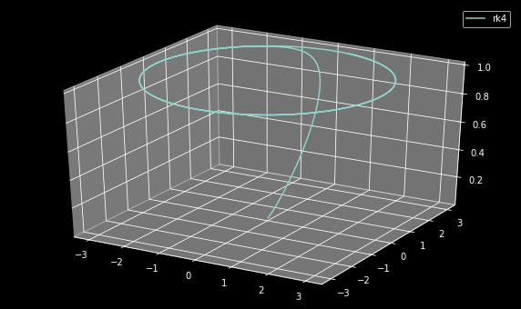

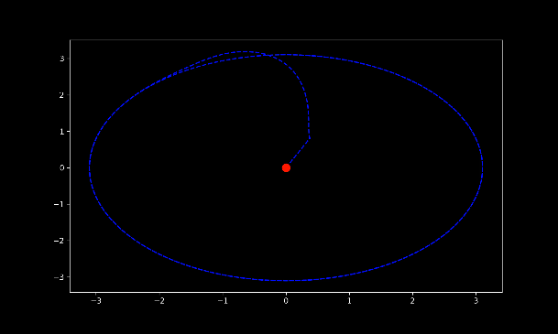

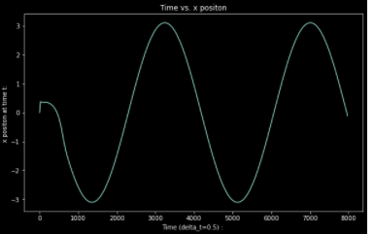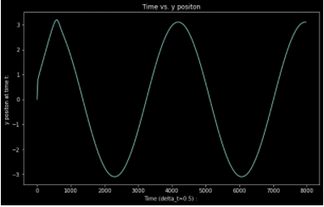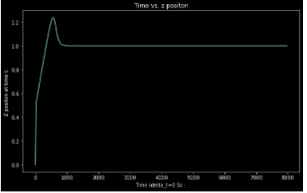

An extension of this project would be to use differential flatness to closely control a quadcopter along the limit cycle trajectory using Coppeliasim for a more realistic simulation of the quadcopter.

**Github:** <https://github.com/rdensamo/CSE498-FinalProject-21-Densamo>

**References**

B. Song, G. Qi and L. Xu, "A Survey of Three-Dimensional Flight Path Planning for Unmanned

Aerial Vehicle," *2019 Chinese Control And Decision Conference (CCDC)*, Nanchang, China, 2019, pp. 5010-5015, doi: 10.1109/CCDC.2019.8832890.

D. Zhou and M. Schwager, "Vector field following for quadrotors using differential flatness,"

*2014 IEEE International Conference on Robotics and Automation (ICRA)*, Hong Kong, China, 2014, pp. 6567-6572, doi: 10.1109/ICRA.2014.6907828.

V. M. Goncalves, L. C. A. Pimenta, C. A. Maia, B. C. O. Dutra and G. A. S. Pereira, "Vector

Fields for Robot Navigation Along Time-Varying Curves in n -Dimensions," in *IEEE Transactions on Robotics*, vol. 26, no. 4, pp. 647-659, Aug. 2010, doi: 10.1109/TRO.2010.2053077.

Ramasamy, Suresh & Wu, Guofan & Sreenath, Koushil. (2014). Dynamically Feasible Motion

Planning through Partial Differential Flatness.. 10.15607/RSS.2014.X.053.

Underactuated Robotics. Underactuated Robotics: Simple Models of Walking and Running. (n.d.). http://underactuated.mit.edu/simple_legs.html.